**CGS - LogMx log viewer installation and configuration guide**

**Last modified:** 10/08/2014

**Author:** Asaf Shochet

**Abstract**

This document will walk you through installation and configuration of the LogMx log viewer to view CGS logs.

**Installation steps**

1. Go to <http://www.logmx.com/download>. It's a trial version - contact IT for the purchased version.
2. Download installation type "Installer (Java included) (58 MB)" for Windows.
3. Install logMX.
4. Run logMX.
5. Click on the "configuration" icon to define a new log parser:

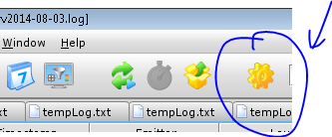

1. Click the "Parsers" tab.
2. Define "Switch to next parser after…" to 2000

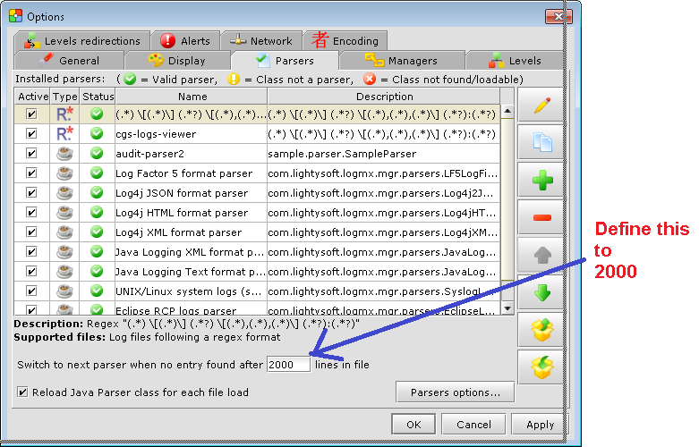

1. Import the log parser:

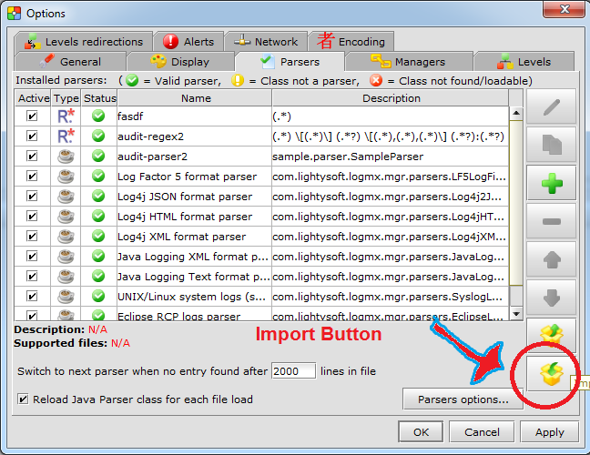

1. Copy logmx.parsers.export file (found next to this word file) to a local folder and import it as the chosen log parser.
2. Open the log file from C:\t2k\tomcat\logs\cgs (you can drag & drop it, open from folder, or connect to SFTP) and you're done.

**Extras:**

Connect to SFTP:

1. Hit File.. -> Open log File ->
2. Choose open file from SFTP (SFTP file manager)
3. Enter details here:

